**Experiment no 9**

**Name:** Shaikh Masood Iqbal

**Roll No.:** 24DDS02

**AIM:** To design and Simulate NAT on the router using Cisco packet tracer/ GNS3

**REQUIREMENTS:** CISCO Packet Tracer

**THEORY:**

To access the Internet, one public IP address is needed, but we can use a private IP address in our private network. The idea of NAT is to allow multiple devices to access the Internet through a single public address. To achieve this, the translation of a private IP address to a public IP address is required. **Network Address Translation (NAT)** is a process in which one or more local IP address is translated into one or more Global IP address and vice versa in order to provide Internet access to the local hosts. Also, it does the translation of port numbers i.e. masks the port number of the host with another port number, in the packet that will be routed to the destination. It then makes the corresponding entries of IP address and port number in the NAT table. NAT generally operates on a router or firewall.

#### Procedure–

1. Create the Network Topology

Connect the PC, Switch, Router, and Server as shown below.

Assign appropriate IP addresses to each device.

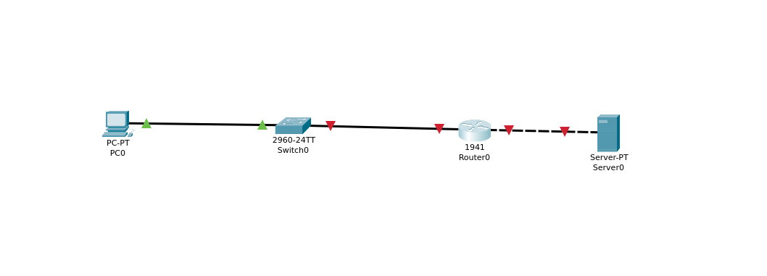

2. Configure the Router using CLI Commands

Open the router CLI and enter the following commands step by step.

Commands:

enable

configure terminal

// Configure GigabitEthernet0/0 (Private Network)

interface GigabitEthernet0/0

ip address 192.168.1.1 255.255.255.0

no shutdown

exit

// Configure GigabitEthernet0/1 (Public Network)

interface GigabitEthernet0/1

ip address 10.0.0.1 255.255.255.0

no shutdown

exit

// Add a default route

ip route 0.0.0.0 0.0.0.0 GigabitEthernet0/1

// Enable NAT

access-list 1 permit 192.168.1.0 0.0.0.255

ip nat inside source list 1 interface GigabitEthernet0/1 overload

// Mark interfaces as inside/outside

interface GigabitEthernet0/0

ip nat inside

exit

interface GigabitEthernet0/1

ip nat outside

exit

3. Verify the Network

After configuration, check connectivity between PC and Server using the ping command.

The network should now be working properly with NAT enabled.

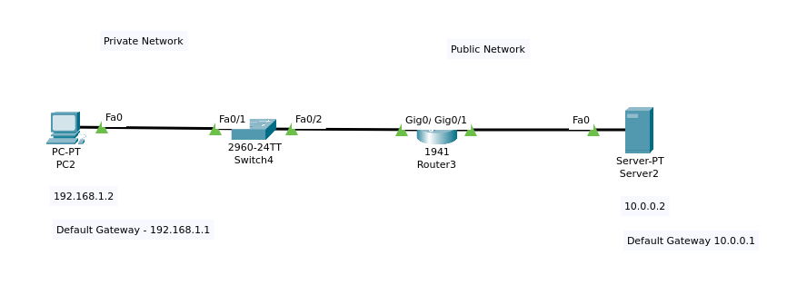

#### Network Address Translation (NAT) working –

Generally, the border router is configured for NAT i.e the router which has one interface in the local (inside) network and one interface in the global (outside) network. When a packet traverse outside the local (inside) network, then NAT converts that local (private) IP address to a global (public) IP address. When a packet enters the local network, the global (public) IP address is converted to a local (private) IP address.

If NAT runs out of addresses, i.e., no address is left in the pool configured then the packets will be dropped and an Internet Control Message Protocol (ICMP) host unreachable packet to the destination is sent.

#### Why mask port numbers ?

Suppose, in a network, two hosts A and B are connected. Now, both of them request for the same destination, on the same port number, say 1000, on the host side, at the same time. If NAT does only translation of IP addresses, then when their packets will arrive at the NAT, both of their IP addresses would be masked by the public IP address of the network and sent to the destination. Destination will send replies to the public IP address of the router. Thus, on receiving a reply, it will be unclear to NAT as to which reply belongs to which host (because source port numbers for both A and B are the same). Hence, to avoid such a problem, NAT masks the source port number as well and makes an entry in the NAT table.

#### NAT inside and outside addresses –

Inside refers to the addresses which must be translated. Outside refers to the addresses which are not in control of an organization. These are the network Addresses in which the translation of the addresses will be done.

* **Inside local address –** An IP address that is assigned to a host on the Inside (local) network. The address is probably not an IP address assigned by the service provider i.e., these are private IP addresses. This is the inside host seen from the inside network.
* **Inside global address –** IP address that represents one or more inside local IP addresses to the outside world. This is the inside host as seen from the outside network.
* **Outside local address –** This is the actual IP address of the destination host in the local network after translation.
* **Outside global address –** This is the outside host as seen from the outside network. It is the IP address of the outside destination host before translation.

#### Network Address Translation (NAT) Types –

There are 3 ways to configure NAT:

1. **Static NAT –** In this, a single unregistered (Private) IP address is mapped with a legally registered (Public) IP address i.e one-to-one mapping between local and global addresses. This is generally used for Web hosting. These are not used in organizations as there are many devices that will need Internet access and to provide Internet access, a public IP address is needed.

Suppose, if there are 3000 devices that need access to the Internet, the organization has to buy 3000 public addresses that will be very costly.

1. **Dynamic NAT –** In this type of NAT, an unregistered IP address is translated into a registered (Public) IP address from a pool of public IP addresses. If the IP address of the pool is not free, then the packet will be dropped as only a fixed number of private IP addresses can be translated to public addresses.

Suppose, if there is a pool of 2 public IP addresses then only 2 private IP addresses can be translated at a given time. If 3rd private IP address wants to access the Internet then the packet will be dropped therefore many private IP addresses are mapped to a pool of public IP addresses. NAT is used when the number of users who want to access the Internet is fixed. This is also very costly as the organization has to buy many global IP addresses to make a pool.

1. **Port Address Translation (PAT) –** This is also known as NAT overload. In this, many local (private) IP addresses can be translated to a single registered IP address. Port numbers are used to distinguish the traffic i.e., which traffic belongs to which IP address. This is most frequently used as it is cost-effective as thousands of users can be connected to the Internet by using only one real global (public) IP address.

#### Advantages of NAT –

* + NAT conserves legally registered IP addresses.
  + It provides privacy as the device’s IP address, sending and receiving the traffic, will be hidden.
  + Eliminates address renumbering when a network evolves.

#### Disadvantage of NAT –

* + Translation results in switching path delays.
  + Certain applications will not function while NAT is enabled.
  + Complicates tunneling protocols such as IPsec.
  + Also, the router being a network layer device, should not tamper with port numbers(transport layer) but it has to do so because of NAT.

**OUTPUT:**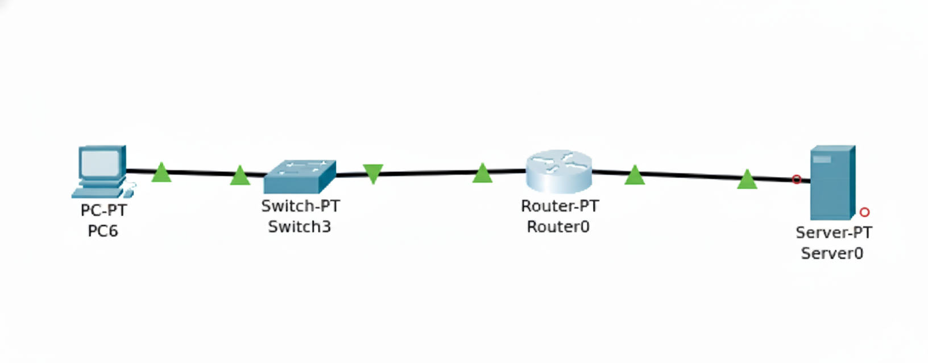

**CONCLUSION:** We have studied the NAT using cisco packet tracer.